1. **INTRODUCTION:**

Life is all about experiencing new ideas and adding grace and charm. For this you need to explore new things from time to time. The real panorama of beauty is to be seen while trekking. The desire to see the unseen, to explore the unexplored, the will to know your limits to push has upsurge the visitors to trekking. But all these desire remains only in imagination because they don’t have access to any guidance for that particular place and information related to it.

“hitrekkers” is the trekking platform that helps traveler’s to meet with their imagination and provides the precise content to follow throughout their journey. So, it is the recommendation engine that provides the best fit trekking destinations according to the traveler’s query. Furthermore, it acts as a digital guide with concise content to follow.

1. **PROBLEM DEFINITION:**

People now a day are being more specific to any subject matter. They expect detailed and perfect information of whether it is of sports, food, news, politics or any travel related problems. Trekkers have difficulties to find information regarding their destinations. They need to spend lot of time in searching the information regarding the proper place for the trekking purpose.

The future of the existing system has to be seen as one of the continuous changes, where the complexities and the quantities are being grown in the daily basis. The existing system is required to provide a useable and well managed layout and the smoothness in the trekking information system with the minimum requirements and minimum budget.

In existing system, the traveler has to search a lot of websites or have to ask to people which they find in between their way, in order to get the knowledge of the routes or information about the particular trekking destination. Existing system takes a lot of time and thus the traveler have to face even such a situation when they don’t have any time and thus they have to limit themselves into only few places to travel.

1. **OBJECTIVES:**

The primary purpose of this project is to serve traveler through web-based trekking services.

The major purpose of this project is;

* To recommend the perfect destination to the trekkers,
* To guide the trekkers during their trip,
* To help those who are not familiar with trekking,
* To provide the concise information related to trekking.

1. **SCOPE AND LIMITATIONS:**

This website provides a better platform for any user or people who are seeking for places for trekking purpose according to their requirements such as cost, accommodation, duration and many more. The focus of this system is to recommend the best outcomes while the user of the system passes input. “hitrekkers” proceed the searching process by using the keywords, input by users, and matching keywords stored in the database of the system. It provides quick search of information from the database and display it to users.

**Limitations:**

After pre-study of the project, we found that we might face some problems during the implementation process of this project. They may reduce the quality of result when user searches the information in the system. Some of the limitations are:

* It is difficult to rank places in numbers accurately (due to different perception of peoples).
* There is no appropriate range to rank places.

1. **RESARCH METHODOLOGIES:**

**5.1. Literature Review:**

Over the years, tourism has continued to gain massive interest at a global scale. It is a major foreign exchange earner for a good number of advanced and emerging economies. It is also true that information explosion makes it cumbersome times to access relevant information to enhance decision making. This has given rise to the emergence of intelligent systems or mechanisms that facilitate quick access to relevant content found in the Internet [1,2].

For developing countries like Nigeria, tourism is one of the untapped but potentially big income generator. There are about 142 tourist destinations that spread across the 36 states of the federal republic of Nigeria. Whereas some exist naturally, others are manmade [3].

In this era that has witnessed rapid advances in information technology, information overload has become a serious problem to those seeking for information online. Recently, intelligent search mechanisms have been deployed on the web that shows that the problem of information overload can be partially eliminated by providing a platform with more intelligence to assist tourists in the search for relevant information [4].

Google.com is an example of an intelligent search engine that helps users with information and another class of intelligent system that has proven relevant in addressing the problem of information overload are recommender systems [5].

**5.2. Data Collection:**

The data for this project will be collected as a crowdsourcing mechanism from user. Some data about certain places will added by researching their content by visiting fields, Wikipedia and many more.

**5.3. Feasibility Study:**

Feasibility analysis is a part of system analysis carried to confirm that the system being developing is actually feasible or not. This is the phase where any system designers are able to know whether to start the project or not.

We performed some study and analyzed the system and get to know that it is feasible to make the system. Mainly four types of feasibility studies were done with this system analysis, namely: Economic feasibility, Operational feasibility, Technical feasibility and Schedule Feasibility.

**5.3.1. Economic Feasibility:**

Developing and deploying this system has a very little economical cost. All the resources required to develop this system are computers and some hospital information.

For development, PCs that support any Operating System with some applications is sufficient. For deployment, a smart phone or PC with internet is required. During data collection too, not much cost was spent and same with time as well. Further, it does not cost much to develop and access this system and hence, we can say it is economically feasible to develop the system.

**5.3.2.** **Operational Feasibility:**

Proposed project is beneficial only if they are feasible into real world implemented system, which will meet the user requirements. This system provides a simple user interface, which can be easily used by any type of users having basic idea of using smart phones and PCs. This system will provide correct results according to the way the system needs to do. Hence, this system is operationally feasible too.

* + 1. **Technical Feasibility:**

We can say that the current web application, we are building, is technically feasible. This system is built using simple programming language and design, which can be used by any users and can get better place, which contain information regarding different services. It will run on all the existing web browsers with latest version and even in smart phones.

* + 1. **Schedule Feasibility:**

A system is said to be scheduled feasible if it is implemented within the planned scheduled. We carried out the study on how much it will take to complete the task after studying the requirements and proposed plan.

We proposed the rough timeline so that we it would help us to perform our different project activities. Following Gantt chart shows the proposed schedule to perform the project:



*Fig: - Gantt chart for the proposed system*

Thus, creating the schedule and working on it makes it easier for developers to finish the project on time. Hence, this project is feasible if we completed this task within the designed Gantt chart.

* 1. **Requirement Analysis:**

While developing a system and before implementing it, it is necessary to analyze the whole system requirements. It is categorized into mainly two parts, namely: functional and non-functional requirements.

**5.4.1.** **Functional Requirements:**

A functional requirement describes what a software system should do when it is given input. Some of the functional requirements are given below:

* Information about the different places.
* Users can provide their requirement as input.
* Admin can add places, edit places, and delete places.
* Users gets the recommendation and can review the places.

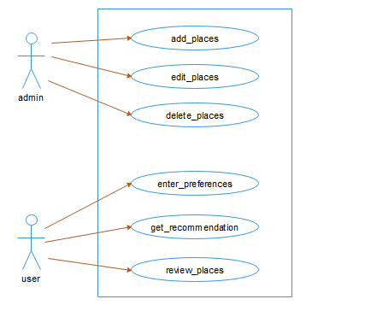

*Fig: - Use case diagram for the system*

**5.4.2. Non-Functional Requirements:**

A non-functional requirement describes how the system performs a certain function. Non-functional requirements generally specify the system’s quality attributes or characteristics.

Typical non-functional requirements include:

* This system uses vector space method to compare and produce the result and takes short period to display the result.
* The system should be capable of supporting large number of visitors.
* The users should follow the input pattern to search the destinations.
  1. **Proposed System:**

In the proposed system, the users open our web application in the browser. In order to get recommendation, the best fit trekking destination, the system asks a user to fill some series of question. Question are designed from well-researched parameters. After this, systems evaluate that data based on an AI algorithm and gives an output of the best possible recommendation with ranking. Users can find a separate digital guide for each trekking destination. Users can give their review & rating for each destination.

**5.5.1. Algorithm Implementation:**

We use Cosine Similarity algorithm for processing information and produce output. Cosine similarity method measures the similarity between two objects based on an angle formed by two objects in vector space. The cosine similarity ranges between 0 and 1 if the values in vectors are positive. A cosine similarity of 1 represents complete similarity between two objects and that of 0 represents complete dissimilarity.

The formula for calculation is:

Cos (a, b) = (a.b)/ (||a||×||b||)

where, ||a|| and ||b|| are the Euclidean norms of vectors a and b, respectively, and a. b is dot product between vectors a and b.

**5.5.2. Block Diagram:**

A block diagram is a diagram showing in schematic form the general arrangement of the parts or components of a system or process. There are four components in the design. First component is the user who provides their requirements, the second component is the system that takes user input and provides the result to user, the third component is the algorithm that calculates the cosine value and matches with the stored result and finally the last component is the database where the data are stored. Here, after the login in the system, the tasks that are done in the system are represented below:

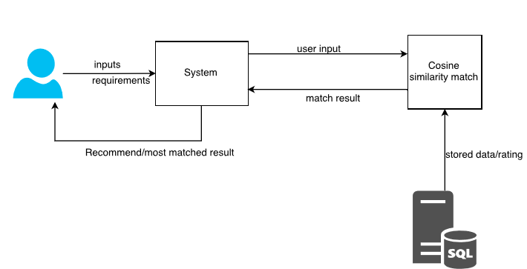

*Fig: - Block Diagram of the system*

* 1. **Implementation Tools:**

This is the phase where we are actually building the system. Firstly, the whole information that we gathered are studied, analyzed and then it was processed to build an actual system. Different tools and technologies that we have used are given below:

**HTML, CSS, BOOTSTRAP**

In this system, HTML is used to display the data in the web browser. Interactive forms are created using HTML codes. Many pages include HTML codes that also links other pages and codes. In the header section of HTML tag, designing link are places so that it is accessed in every page.

CSS, used as a designing tool, helps the interface look much better. Bootstrap, so called framework of CSS, contains various classes for designing the interface. It gives better shape to CSS and make the page more interactive and good looking. We have used Bootstrap classes to make nice frame of design.

**PHP and Sublime Text**

We have used PHP, as a server-side scripting language, to build this project using the well-known PHP framework i.e. Laravel framework, which is easier and better way to create a project.

For designing and coding, we have used popular text editor called Sublime text which makes more easier to do tasks, have better interface and easy to communicates with the different sub folders and pages.

**MySQL and XAMPP Server**

We use MySQL as a database language for storing and communicating information with the database. We have created altogether two tables and some of them relate to each other.

In this system, we have used XAMPP server to connect with the database.

**Edraw Max**

In the system structuring part of the report organization, we have drawn Use Case Diagram, Block Diagram and Flow Diagram with the help of the case tool called Edraw Max. It is an easy tool for constructing such diagrams providing necessary images, shapes etc. It also provides some standards that are available in designing.

**REFERENCES:**

[1] Abdulhamid S.M. & Gana U., *“Destination Information Management System for Tourist: Computer Science and Telecommunications”,* Georgian Electronic Scientific Journal, 2010.

[2] Adebayo, W.J., *“The Economic Impact of Tourism Development: Journal of Tourism”,* Hospitality and Sports, 2014.

[3] Adora, C.U., *“Managing Tourism in Nigeria: Management Science and Engineering”,* American Scientific Research Journal for Engineering, Technology, and Sciences, 2010.

[4] Anastasia A., Panagiota D. & Georgios M., *“A Web-Based Prototype for Personalized Tourism Destination Discovery and Management: Technological Educational Institute of Athens”,* Athens, 2012.

[5] Daramola, J.O., *“A Software Product Line Approach to Ontology-Based Recommendations In E-Tourism Systems: School Project”*, Covenant University, Computer and Information Science, 2009.